**EXPERIMENT – 6**

**AIM :**

Write queries to implement JOINS

**THEORY :**

In this experiment we will see the implementation of SQL JOINS. SQL joins are used to fetch/retrieve data from two or more data tables, based on a join condition. A join condition is a relationship among some columns in the data tables that take part in SQL join. Basically data tables are related to each other with keys. We use these keys relationship in SQL joins.

**TYPES OF JOINS :-**

* **INNER JOIN –** Inner join returns only those records/rows that match/exists in both the tables.
* **LEFT OUTER JOIN –** Left outer join returns all records/rows from left table and from right table returns only matched records. If there are no columns matching in the right table, it returns NULL values
* **RIGHT OUTER JOIN –** Right outer join returns all records/rows from right table and from left table returns only matched records. If there are no columns matching in the left table, it returns NULL values.
* **FULL OUTER JOIN –** Full outer join combines left outer join and right outer join. This join returns all records/rows from both the tables.If there are no columns matching in the both tables, it returns NULL values.
* **CROSS JOIN –**This join returns records/rows that are multiplication of record number from both the tables means each row on left table will related to each row of right table.
* **SELF JOIN –** Self join is used to join a database table to itself, particularly when the table has a Foreign key that references its own Primary Key.

**PROCEDURE :**

**GIVEN TABLES:**

1. 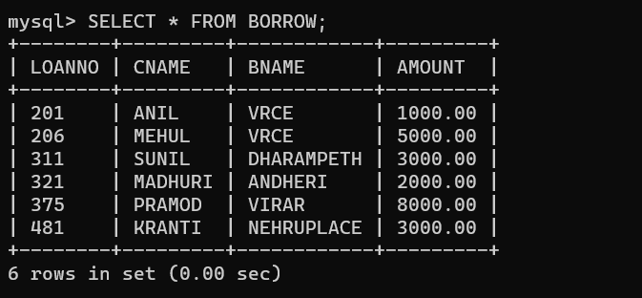**BORROW:**

**2. CUSTOMERS:**

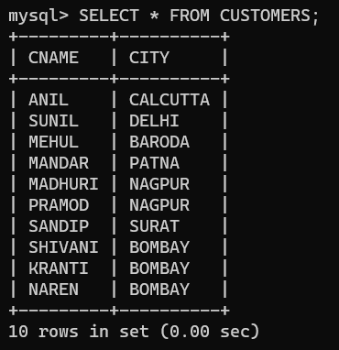

**3. BRANCH:**

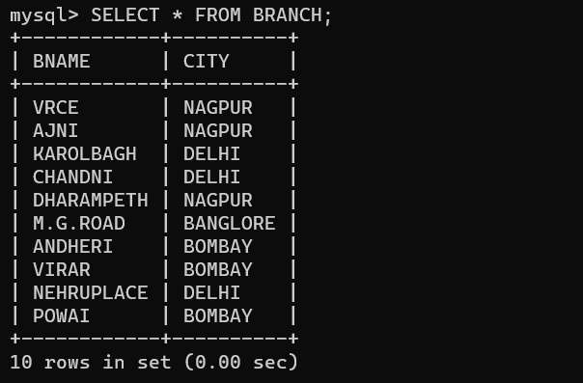

**4.DEPOSIT:**

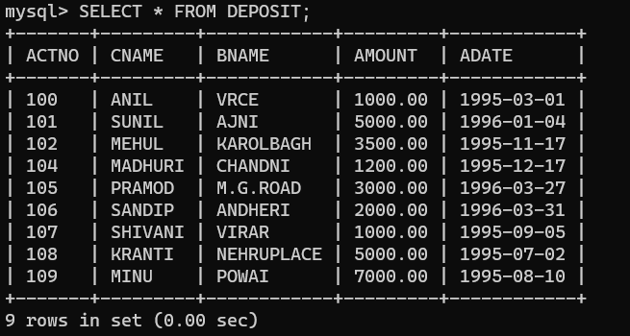

**QUERIES BASED ON SQL JOINS:**

**QUERY(i) :** Give name of customers having living city NAGPUR and branch city DELHI.

**OUTPUT:**

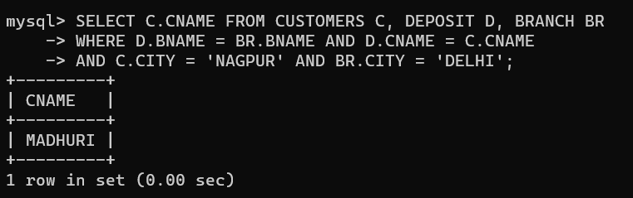

**QUERY (ii):** Give names of customers having same living city as their branch city.

**OUTPUT:**

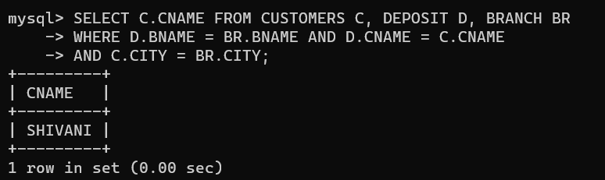

**QUERY (iii):** Give names of customers who are borrowers as well as depositors and having living city NAGPUR .

**OUTPUT:**

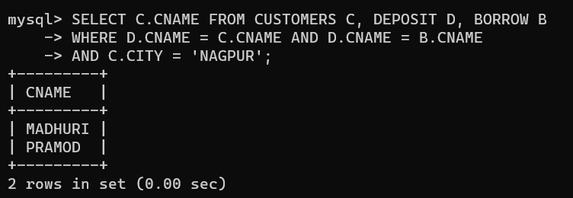

**QUERY (iv):** Give names of depositors having same living city as that of SHIVANI and having deposit greater than 2000.

**OUTPUT:**

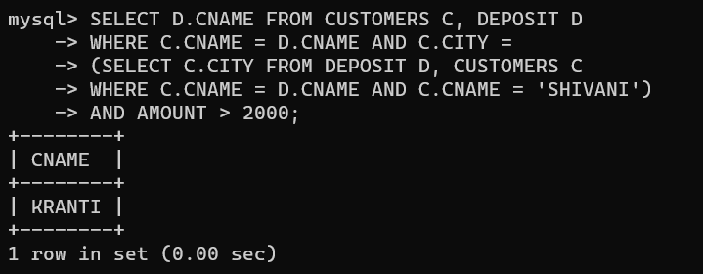

**QUERY (v):** List all customers who are both depositors and borrowers and living in same city as MADHURI.

**QUERY (vi):** List all cities where branches of ANIL and SUNIL are located.

**OUTPUT:**

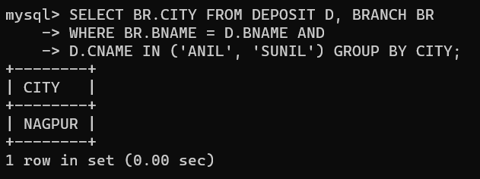

**QUERY (vii):** List all the customers name and AMOUNT living in city where either PRAMOD or KRANTI is living.

**OUTPUT:**

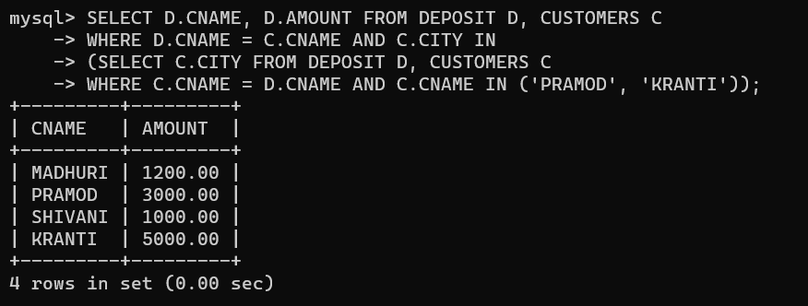

**QUERY (viii):** List AMOUNT for depositors living in city where MADHURI is living.

**OUTPUT:**

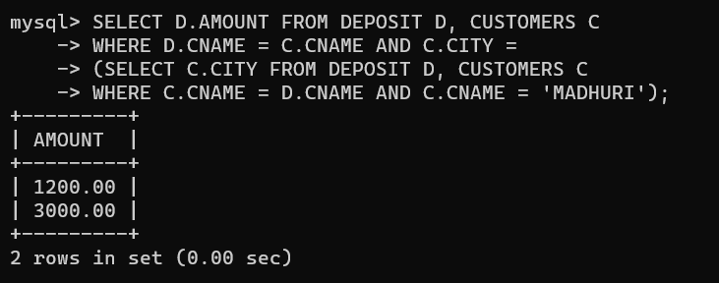

**QUERY (ix):** List the customers who are borrowers or depositors and having living city BOMBAY and branch city same that of MEHUL.

**OUTPUT:**

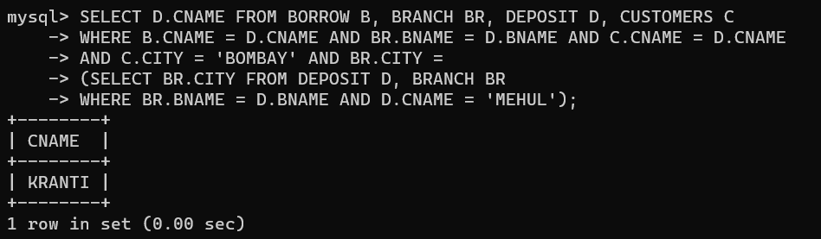

**QUERY (x):** List the customers who are borrowers or depositors and having living same branch cityas that of ANIL.

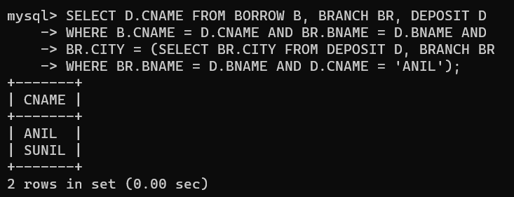**OUTPUT:**